Using IBM Bob, MCP, and watsonx Orchestrate to Generate an Agent
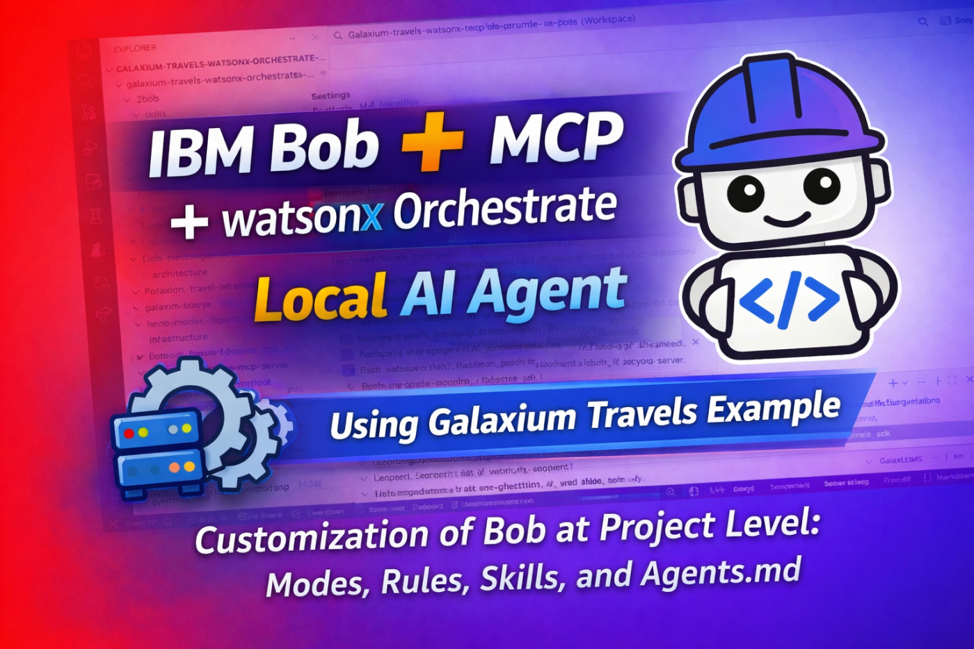
This blog post is related to my YouTube video, to provide an additional simplified documentation.
Table of contents
- Motivation and Introduction
- Why this setup is interesting?
- Understanding IBM Bob first
- Bob customizations
  - Custom mode
  - Rules
  - Skills
  - AGENTS.md
- Galaxium Travels infrastructure
  - What this means?
- Infrastructure together with watsonx Orchestrate
- Infrastructure with Bob and watsonx Orchestrate
- What the video shows in practice?
- Summary
1. Motivation and Introduction
In this post, I want to explain a local setup I use for one practical goal:
using IBM Bob to help generate an agent for watsonx Orchestrate that works with tools exposed by the Galaxium Travels MCP server.
To make that understandable, I also explain the technical context behind it:
- the Galaxium Travels infrastructure
- the role of watsonx Orchestrate in the setup
- the role of IBM Bob in the development workflow
- the main IBM Bob building blocks, such as modes, rules, skills, tools, and MCP connections
The setup is based on these two repositories:
- galaxium-travels-infrastructure-tsuedbro
- galaxium-travels-watsonx-orchestrate-mcp-bob-guide
The first repository provides the application infrastructure.
The second repository provides the practical guide for connecting that infrastructure to watsonx Orchestrate and preparing IBM Bob for the agent-generation workflow.
This post is the architecture and learning story behind the video I recorded on 29. March 2026.
The practical outcome is to show how Bob can support the generation and configuration of an agent in watsonx Orchestrate that uses the tools from the Galaxium Travels MCP server.
YouTube Video: https://youtu.be/QRb2_ZVlynE
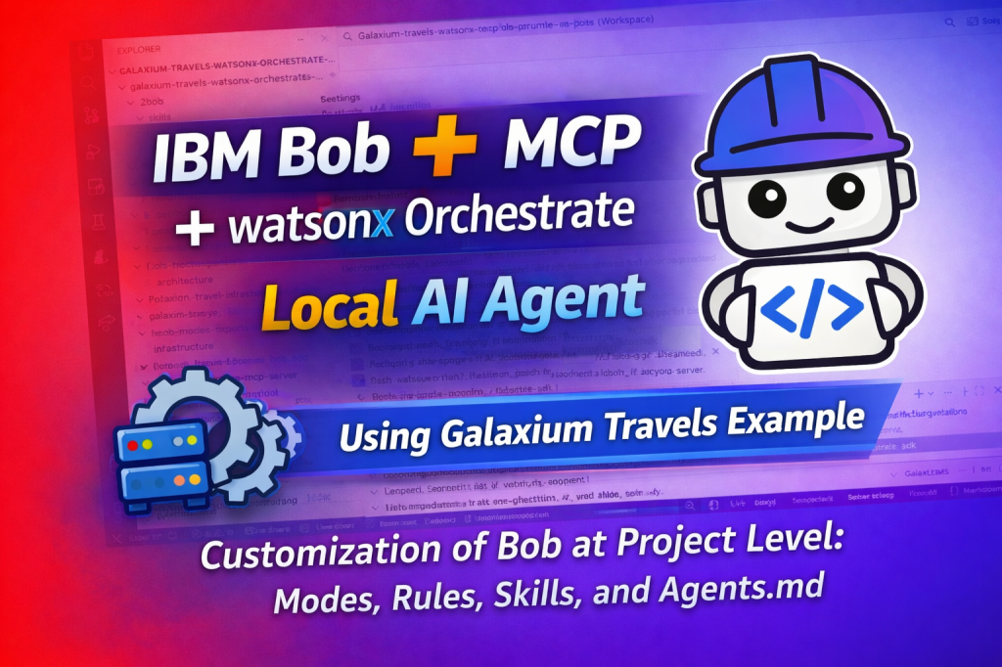
2. Why this setup is interesting?
Many examples focus on only one part:
- only the application
- only the agent
- only the IDE
- only the protocol
But in real projects, these parts work together.
That is why I like this setup. It makes the full path visible:
- local application infrastructure
- MCP-based service access
- local orchestration with watsonx Orchestrate
- AI-supported development with IBM Bob
The important point is this:
the setup is not only for understanding the architecture.
It is prepared so that IBM Bob can help generate an agent for watsonx Orchestrate based on the tools exposed by the Galaxium Travels MCP server.
That makes the environment useful both for learning and for practical implementation.
3. Understanding IBM Bob first
Before using Bob in a project, it helps to understand its main building blocks.
In my diagram, Bob is shown as an IDE that works with:
- Modes
- Rules
- Skills
- Tools
- MCPs
This is important, because Bob is not only a chat interface.
It is better to think about it as a structured development environment:
- Modes define how Bob should work
- Rules define constraints and expectations
- Skills provide reusable project knowledge
- Tools provide executable functions
- MCPs connect Bob to external systems
So Bob can become the center of a guided development workflow.
4. Bob customizations
The Bob setup in this repository is not generic.
The repository already contains project-local Bob configuration files.
These files help prepare Bob for this exact Galaxium Travels workflow.
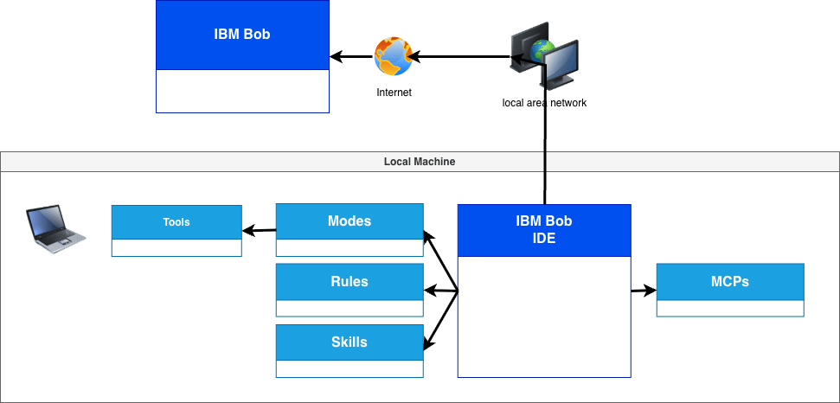
4.1 Custom mode
The file .bob/custom_modes.yaml defines one custom mode named Galaxium Travels Developer.
This mode is intended for:
- Python development
- watsonx Orchestrate integration
- MCP server work
- container-based local development
- authentication
- debugging
- API integration tasks
The enabled groups are:
- read
- edit
- browser
- command
- mcp
- modes
The instructions also tell Bob to:
- use Python
- prefer maintainable solutions
- respect the existing project structure
- stay compatible with local and container-based workflows
- consider MCP design and watsonx Orchestrate integration
4.2 Rules
The .bobrules folder contains repository-specific rules.
In the current structure, this includes files such as:
- coding-style.md
- watsonx-orchestrate-configurations.md
The role of these files is clear: they give Bob coding and project behavior constraints for this repository.
4.3 Skill
The repository contains one skill file in .bob/skills named:
galaxium_travels_watsonx_orchestrate_customization_developer.md
This skill supports development for watsonx Orchestrate Developer Edition customization work in this repository.
In practice, that means Bob gets project-specific guidance instead of working only from the general prompt context.
4.4 AGENTS.md
The repository also includes an AGENTS.md file as part of the active Bob-related setup.
In this project, I see it as a compact repository-level control file for agent behavior.
It complements the custom mode, rules, and skill by adding one more layer of project guidance.
5. Galaxium Travels infrastructure
The next diagram shows the local application itself.
The main idea is simple:
- a browser loads the UI
- the UI talks to the MCP service
- the MCP backend contains the business logic
- the backend stores data in SQLite
The setup uses a local Docker Compose environment with these main parts:
- Booking UI (Flask)
- MCP Booking System
- SQLite
Authentication can be done with:
- OAuth token validation
- Basic Auth
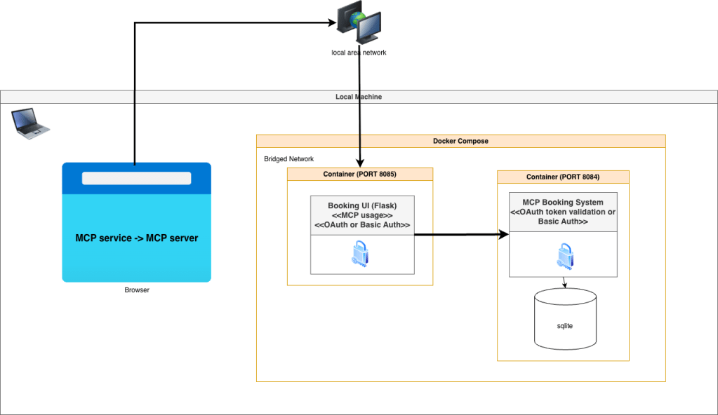
What this means?
The key idea is:
The MCP server is not only for AI agents.
It can also act as the service layer for the application itself.
That is one reason why I find this setup useful.
It helps discuss architecture, not only tools.
6. Infrastructure together with watsonx Orchestrate
The next step adds watsonx Orchestrate Developer Edition.
In the diagram, it runs locally and connects the agent layer with the MCP-based backend.
The important concepts are:
- Agent
- Tools
- Connection
This is the point where the setup changes from a local MCP application into a local agent environment.
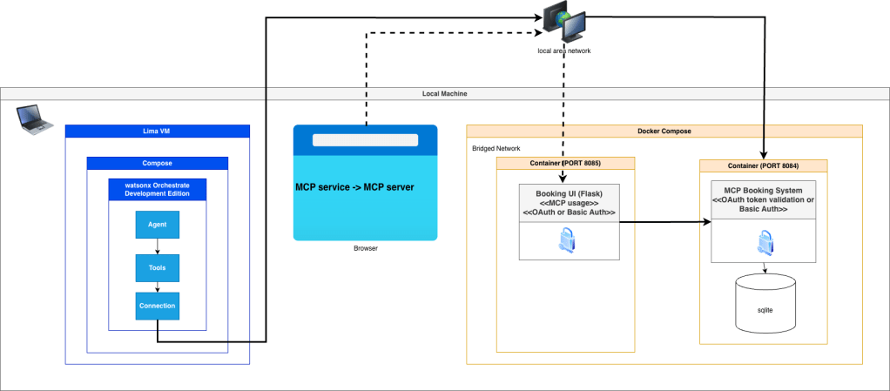
Now the infrastructure is not only something a browser can use.
It becomes something an agent can use through configured tools and connections.
7. Understanding the infrastructure with Bob and watsonx Orchestrate
The last diagram combines everything:
- the local Galaxium Travels MCP backend
- the local watsonx Orchestrate Developer Edition
- the local watsonx Orchestrate MCP server
- the Bob IDE with modes, rules, skills, tools, and MCP connections
- an external documentation MCP endpoint
This is the most interesting part for me.
Because this is the point where Bob becomes more than an editor assistant.
Bob can work closer to:
- the local application backend
- the local orchestration environment
- the documentation source
This is also the point where the prepared Bob setup can support the practical goal of this project:
helping generate and configure an agent in watsonx Orchestrate that uses the tools provided by the Galaxium Travels MCP server.Instead of only writing code, Bob can help navigate the architecture and prepare the integration work.
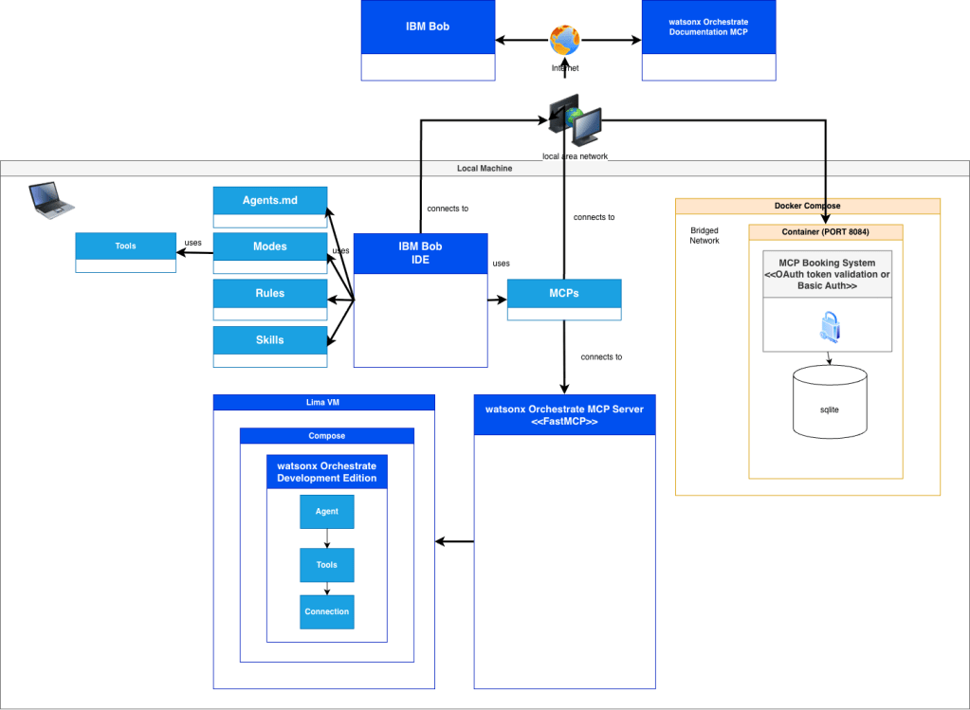
8. What the video shows in practice?
The video is not only about the architecture behind the setup.
It also shows the practical workflow step by step.
After explaining the role of IBM Bob, MCP, the Galaxium Travels infrastructure, and watsonx Orchestrate Developer Edition, the video moves into the actual hands-on flow.
This practical part includes:
- starting with the IBM Bob prompt
- submitting the prompt
- reviewing the task plan created by IBM Bob
- configuring the environment file
- running the required commands
- importing MCP tools
- generating the agent configuration
- testing the generated result
This is an important part of the walkthrough.
It shows that the setup is not only useful for understanding the different components.
It also shows how these components can be used together in a reproducible workflow to generate an agent for watsonx Orchestrate that uses the tools exposed by the Galaxium Booking MCP Server.
That practical flow is the main reason why I think this example is useful.
It connects the architectural understanding with the actual implementation steps.
9. Summary
The practical value of this setup is not only that the environment runs locally.
The practical value is that IBM Bob can work with the prepared repository structure, MCP connections, and watsonx Orchestrate environment to help generate an agent that uses the tools exposed by the Galaxium Booking MCP Server.
That makes this setup useful not only for learning, but also as a reproducible starting point for implementation.
Note: This post reflects my own ideas and experience; AI was used only as a writing and thinking aid to help structure and clarify the arguments, not to define them.
#AI, #MCP, #ModelContextProtocol, #RESTAPI, #SoftwareArchitecture, #AIArchitecture, #AIAgents, #GenerativeAI, #DeveloperTools, #OpenSource, #Containerized, #CloudNative, #GalaxiumTravels

AI generated Podcast Episode: AI Coding Assistants, Agentic IDEs, and Privacy: From Chatbots to Operational Systems
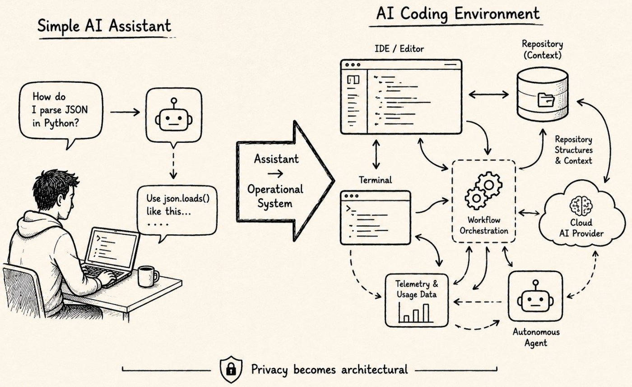
Original Post From AI Coding Assistants to Autonomous Engineering Systems made in 06/2026
Pip: Welcome to a blog where the question “what happens to my code when I hit send?” turns out to have a genuinely complicated answer — and thomassuedbroecker has spent close to a year working through it.
Mara: This episode covers one deep investigation into AI coding assistants, agentic IDEs, and what privacy actually means when your development environment starts acting like an autonomous agent. Let’s start with what that shift means in practice.
AI Coding Assistants, Agentic IDEs, and Privacy
Pip: The framing here is not “does this tool train on my data” — that’s the old question. The new question is what happens when your AI assistant can see your repository, your terminal, your workflow metadata, and your unfinished ideas all at once.
Mara: The post sets this up directly: “Privacy is no longer just a checkbox. It is increasingly becoming an architectural design decision of your development environment for the entire SDLC.”
Pip: That reframe matters. It moves privacy from a policy you accept at signup to a structural choice you make when you decide how your tooling is wired together.
Mara: Right, and the post breaks that down into distinct layers — training, retention, logging, telemetry, human review, repository context access, and tool integration. Most users only think about the training layer.
Pip: Which is a bit like worrying about whether your landlord reads your mail while ignoring the security camera in the hallway.
Mara: The post compares six platforms on exactly these dimensions: local Granite models, IBM Bob, Claude, ChatGPT and OpenAI, Gemini, and GitHub Copilot. Local Granite running via Ollama ranks highest for technical isolation because prompts and code stay inside your environment by default.
Pip: IBM Bob earns the second spot largely on the strength of one unusually direct statement.
Mara: IBM states: “Your prompts are not used as training data.” The post notes this is an important and unusually direct claim, but it does not automatically mean zero telemetry, zero retention, or zero logging.
Pip: So “not trained on” and “not seen” are two different things — and the post is careful to keep those separate throughout.
Mara: Claude gets credit for more privacy-focused wording and configurable routing, including documented support for local model workflows through Claude Code. ChatGPT’s structure is described as one of the most complicated in the comparison, partly because OpenAI separates consumer, API, enterprise, and open-model deployments with different data policies for each.
Pip: GitHub Copilot lands at the bottom of the privacy ranking, which is notable given it’s also the cheapest option at around ten dollars a month.
Mara: The post makes that tradeoff explicit. GitHub Copilot has the deepest IDE and repository integration of any tool in the comparison, and the post states that its privacy profile now depends strongly on the selected workflow, the model provider, and the routing architecture.
Mara: There’s also a pricing section that converts IBM Bob’s Bobcoin system into USD equivalents — one Bobcoin equals fifty cents — to make the plans comparable across all six platforms.
Pip: And the post closes with a point that lands harder than a pricing table: the real cost of AI tooling isn’t only money. You may also be paying with repository context, telemetry, workflow visibility, and the operational exposure of ideas that aren’t finished yet.
Mara: That connects to a broader argument in the post’s final section — that developer context itself may contain economically valuable knowledge, which makes the privacy question about more than just data hygiene.

Pip: The shift from chatbot to workflow participant changes what privacy even means for a developer.
Mara: And the honest answer to “which tool is most private” turns out to be: it depends entirely on your threat model and how you wire the system together.
Pip: More architecture, less checkbox. That’s the territory next time too.

Important Note:
The podcast narration was generated using experimental WordPress functionality. It summarizes and interprets the original article, but it may simplify individual details.
For the complete comparison, references, qualifications, and source links, please read the original blog post.
AI products, prices, privacy policies, and technical capabilities can change quickly. The investigation reflects the publicly documented information available when the article was written.
Share this:
- X
- Facebook

Related
AI Coding Assistants, Agentic IDEs, and Privacy: From Chatbots to Operational SystemsMay 28, 2026In "ai"
From Idea to Responsibility: Why AI Coding Needs Engineering ProvenanceAugust 12, 2026In "ai"
Coordinating Multiple Agentic IDEs with a Shared Handoff FileJune 20, 2026In "cloud"

Published by thomassuedbroecker
My name is Thomas Suedbroecker and I work for IBM. I am a customer-oriented, team-oriented and open person, I focus on business success, client's success, innovation and skills. All opinions in my blog posts are my own. My objective is to provide developers help and guides, to enable themself on Cloud development topics and of course the relevant usage of the Development and Operations. I like music and creating own music by playing drums and I started playing the e-guitar (very beginning ;-)). View all posts by thomassuedbroecker
July 29, 2026
ai
#llm, ai, artificial-intelligence, technology
Post navigation
Building a Local-First Blog Review Agent Chain with Claude and Codex
The Rise of Multi-Model Engineering: Is IBM Bob Already Built for the Next Phase?
Leave a comment

Write a comment...
Comment

This site uses Akismet to reduce spam. Learn how your comment data is processed.

Search for:

Categories
- cloud (203)
- ai (51)
- ibm_cloud (42)
- kubernetes (35)
- #container (21)
Tags
- ai (59)
- ibmcloud (59)
- ibmdeveloper (57)
- technology (56)
- #ai (53)
Year
- 2026 (236)
- 2025 (384)
- 2024 (326)
- 2023 (205)
- 2022 (250)
GO operator: Get a frontend application running on a free IBM Cloud Kubernetes cluster!
Video Player
00:00
50:26
Follow me on Twitter
My Tweets
Top Posts & Pages
- Change the index-url in pip.conf
- CheatSheet: Run a PostgreSQL container with Podman and podman-compose
- A Music AI Video Generation: Run Local, Offline, and Free on macOS
- My First Hands-On Experience with IBM Bob: From Planning to RAG Implementation
- The Rise of Multi-Model Engineering: Is IBM Bob Already Built for the Next Phase?
Follow Blog via Email

Enter your email address to follow this blog and receive notifications of new posts by email.
Email Address:
Follow

Join 1,616 other subscribers
#AgenticAI#agents#ai#aiagents#AIEngineering#automation#bash#bashscript#bashscripting#chatgpt#cheatsheet#CloudNativeStarter#CNS#codeengine#container#docker#go#IBM#IBMCloud#Java#javascript#Keycloak#Kubernetes#llm#MicroProfile#OpenShift#opensource#Operator#operatorlearningjourney#operatorsdk#python#RESTAPI#vpc#watsonx#watsonxOrchestrateaiartificial-intelligencedockeribmcloudibmdeveloperjavakubernetesOpenShiftprogrammingtechnology
Archives
- August 2026 (2)
- July 2026 (2)
- June 2026 (5)
- May 2026 (2)
- April 2026 (4)
- March 2026 (3)
- February 2026 (3)
- January 2026 (4)
- December 2025 (2)
- November 2025 (4)
- October 2025 (2)
- September 2025 (2)
- August 2025 (1)
- July 2025 (2)
- June 2025 (3)
- May 2025 (2)
- March 2025 (1)
- February 2025 (4)
- January 2025 (2)
- December 2024 (5)
- November 2024 (3)
- October 2024 (4)
- August 2024 (5)
- June 2024 (3)
- May 2024 (2)
- April 2024 (1)
- March 2024 (6)
- February 2024 (1)
- January 2024 (7)
- December 2023 (2)
- November 2023 (1)
- October 2023 (4)
- September 2023 (2)
- August 2023 (3)
- May 2023 (8)
- April 2023 (1)
- March 2023 (4)
- February 2023 (6)
- January 2023 (7)
- December 2022 (8)
- November 2022 (2)
- October 2022 (2)
- September 2022 (4)
- August 2022 (2)
- July 2022 (6)
- June 2022 (1)
- May 2022 (3)
- April 2022 (6)
- March 2022 (11)
- February 2022 (7)
- January 2022 (5)
- December 2021 (5)
- November 2021 (8)
- October 2021 (1)
- September 2021 (2)
- August 2021 (4)
- July 2021 (1)
- June 2021 (7)
- May 2021 (4)
- April 2021 (4)
- March 2021 (2)
- February 2021 (3)
- January 2021 (2)
- December 2020 (2)
- November 2020 (3)
- October 2020 (4)
- September 2020 (3)
- August 2020 (2)
- July 2020 (1)
- June 2020 (8)
- May 2020 (4)
- April 2020 (2)
- March 2020 (3)
- February 2020 (4)
- January 2020 (3)
- December 2019 (2)
- November 2019 (4)
- September 2019 (3)
- August 2019 (7)
- June 2019 (4)
- April 2019 (3)
- March 2019 (3)
- February 2019 (3)
- December 2018 (2)
- November 2018 (5)
- October 2018 (2)
- September 2018 (5)
My music on Spotify

Type your email…
Subscribe

AI generated Podcast Episode: AI Coding Assistants, Agentic IDEs, and Privacy: From Chatbots to Operational Systems

Original Post From AI Coding Assistants to Autonomous Engineering Systems made in 06/2026
Pip: Welcome to a blog where the question “what happens to my code when I hit send?” turns out to have a genuinely complicated answer — and thomassuedbroecker has spent close to a year working through it.
Mara: This episode covers one deep investigation into AI coding assistants, agentic IDEs, and what privacy actually means when your development environment starts acting like an autonomous agent. Let’s start with what that shift means in practice.
AI Coding Assistants, Agentic IDEs, and Privacy
Pip: The framing here is not “does this tool train on my data” — that’s the old question. The new question is what happens when your AI assistant can see your repository, your terminal, your workflow metadata, and your unfinished ideas all at once.
Mara: The post sets this up directly: “Privacy is no longer just a checkbox. It is increasingly becoming an architectural design decision of your development environment for the entire SDLC.”
Pip: That reframe matters. It moves privacy from a policy you accept at signup to a structural choice you make when you decide how your tooling is wired together.
Mara: Right, and the post breaks that down into distinct layers — training, retention, logging, telemetry, human review, repository context access, and tool integration. Most users only think about the training layer.
Pip: Which is a bit like worrying about whether your landlord reads your mail while ignoring the security camera in the hallway.
Mara: The post compares six platforms on exactly these dimensions: local Granite models, IBM Bob, Claude, ChatGPT and OpenAI, Gemini, and GitHub Copilot. Local Granite running via Ollama ranks highest for technical isolation because prompts and code stay inside your environment by default.
Pip: IBM Bob earns the second spot largely on the strength of one unusually direct statement.
Mara: IBM states: “Your prompts are not used as training data.” The post notes this is an important and unusually direct claim, but it does not automatically mean zero telemetry, zero retention, or zero logging.
Pip: So “not trained on” and “not seen” are two different things — and the post is careful to keep those separate throughout.
Mara: Claude gets credit for more privacy-focused wording and configurable routing, including documented support for local model workflows through Claude Code. ChatGPT’s structure is described as one of the most complicated in the comparison, partly because OpenAI separates consumer, API, enterprise, and open-model deployments with different data policies for each.
Pip: GitHub Copilot lands at the bottom of the privacy ranking, which is notable given it’s also the cheapest option at around ten dollars a month.
Mara: The post makes that tradeoff explicit. GitHub Copilot has the deepest IDE and repository integration of any tool in the comparison, and the post states that its privacy profile now depends strongly on the selected workflow, the model provider, and the routing architecture.
Mara: There’s also a pricing section that converts IBM Bob’s Bobcoin system into USD equivalents — one Bobcoin equals fifty cents — to make the plans comparable across all six platforms.
Pip: And the post closes with a point that lands harder than a pricing table: the real cost of AI tooling isn’t only money. You may also be paying with repository context, telemetry, workflow visibility, and the operational exposure of ideas that aren’t finished yet.
Mara: That connects to a broader argument in the post’s final section — that developer context itself may contain economically valuable knowledge, which makes the privacy question about more than just data hygiene.

Pip: The shift from chatbot to workflow participant changes what privacy even means for a developer.
Mara: And the honest answer to “which tool is most private” turns out to be: it depends entirely on your threat model and how you wire the system together.
Pip: More architecture, less checkbox. That’s the territory next time too.

Important Note:
The podcast narration was generated using experimental WordPress functionality. It summarizes and interprets the original article, but it may simplify individual details.
For the complete comparison, references, qualifications, and source links, please read the original blog post.
AI products, prices, privacy policies, and technical capabilities can change quickly. The investigation reflects the publicly documented information available when the article was written.
Share this:
- X
- Facebook

Related
AI Coding Assistants, Agentic IDEs, and Privacy: From Chatbots to Operational SystemsMay 28, 2026In "ai"
From Idea to Responsibility: Why AI Coding Needs Engineering ProvenanceAugust 12, 2026In "ai"
Coordinating Multiple Agentic IDEs with a Shared Handoff FileJune 20, 2026In "cloud"

Published by thomassuedbroecker
My name is Thomas Suedbroecker and I work for IBM. I am a customer-oriented, team-oriented and open person, I focus on business success, client's success, innovation and skills. All opinions in my blog posts are my own. My objective is to provide developers help and guides, to enable themself on Cloud development topics and of course the relevant usage of the Development and Operations. I like music and creating own music by playing drums and I started playing the e-guitar (very beginning ;-)). View all posts by thomassuedbroecker
July 29, 2026
ai
#llm, ai, artificial-intelligence, technology
Post navigation
Building a Local-First Blog Review Agent Chain with Claude and Codex
The Rise of Multi-Model Engineering: Is IBM Bob Already Built for the Next Phase?
Leave a comment

Write a comment...
Comment

This site uses Akismet to reduce spam. Learn how your comment data is processed.

Search for:

Categories
- cloud (203)
- ai (51)
- ibm_cloud (42)
- kubernetes (35)
- #container (21)
Tags
- ai (59)
- ibmcloud (59)
- ibmdeveloper (57)
- technology (56)
- #ai (53)
Year
- 2026 (236)
- 2025 (384)
- 2024 (326)
- 2023 (205)
- 2022 (250)
GO operator: Get a frontend application running on a free IBM Cloud Kubernetes cluster!
Video Player
00:00
50:26
Follow me on Twitter
My Tweets
Top Posts & Pages
- Change the index-url in pip.conf
- CheatSheet: Run a PostgreSQL container with Podman and podman-compose
- A Music AI Video Generation: Run Local, Offline, and Free on macOS
- My First Hands-On Experience with IBM Bob: From Planning to RAG Implementation
- The Rise of Multi-Model Engineering: Is IBM Bob Already Built for the Next Phase?
Follow Blog via Email

Enter your email address to follow this blog and receive notifications of new posts by email.
Email Address:
Follow

Join 1,616 other subscribers
#AgenticAI#agents#ai#aiagents#AIEngineering#automation#bash#bashscript#bashscripting#chatgpt#cheatsheet#CloudNativeStarter#CNS#codeengine#container#docker#go#IBM#IBMCloud#Java#javascript#Keycloak#Kubernetes#llm#MicroProfile#OpenShift#opensource#Operator#operatorlearningjourney#operatorsdk#python#RESTAPI#vpc#watsonx#watsonxOrchestrateaiartificial-intelligencedockeribmcloudibmdeveloperjavakubernetesOpenShiftprogrammingtechnology
Archives
- August 2026 (2)
- July 2026 (2)
- June 2026 (5)
- May 2026 (2)
- April 2026 (4)
- March 2026 (3)
- February 2026 (3)
- January 2026 (4)
- December 2025 (2)
- November 2025 (4)
- October 2025 (2)
- September 2025 (2)
- August 2025 (1)
- July 2025 (2)
- June 2025 (3)
- May 2025 (2)
- March 2025 (1)
- February 2025 (4)
- January 2025 (2)
- December 2024 (5)
- November 2024 (3)
- October 2024 (4)
- August 2024 (5)
- June 2024 (3)
- May 2024 (2)
- April 2024 (1)
- March 2024 (6)
- February 2024 (1)
- January 2024 (7)
- December 2023 (2)
- November 2023 (1)
- October 2023 (4)
- September 2023 (2)
- August 2023 (3)
- May 2023 (8)
- April 2023 (1)
- March 2023 (4)
- February 2023 (6)
- January 2023 (7)
- December 2022 (8)
- November 2022 (2)
- October 2022 (2)
- September 2022 (4)
- August 2022 (2)
- July 2022 (6)
- June 2022 (1)
- May 2022 (3)
- April 2022 (6)
- March 2022 (11)
- February 2022 (7)
- January 2022 (5)
- December 2021 (5)
- November 2021 (8)
- October 2021 (1)
- September 2021 (2)
- August 2021 (4)
- July 2021 (1)
- June 2021 (7)
- May 2021 (4)
- April 2021 (4)
- March 2021 (2)
- February 2021 (3)
- January 2021 (2)
- December 2020 (2)
- November 2020 (3)
- October 2020 (4)
- September 2020 (3)
- August 2020 (2)
- July 2020 (1)
- June 2020 (8)
- May 2020 (4)
- April 2020 (2)
- March 2020 (3)
- February 2020 (4)
- January 2020 (3)
- December 2019 (2)
- November 2019 (4)
- September 2019 (3)
- August 2019 (7)
- June 2019 (4)
- April 2019 (3)
- March 2019 (3)
- February 2019 (3)
- December 2018 (2)
- November 2018 (5)
- October 2018 (2)
- September 2018 (5)
My music on Spotify

Type your email…
Subscribe
My First Hands-On Experience with IBM Bob: From Planning to RAG Implementation
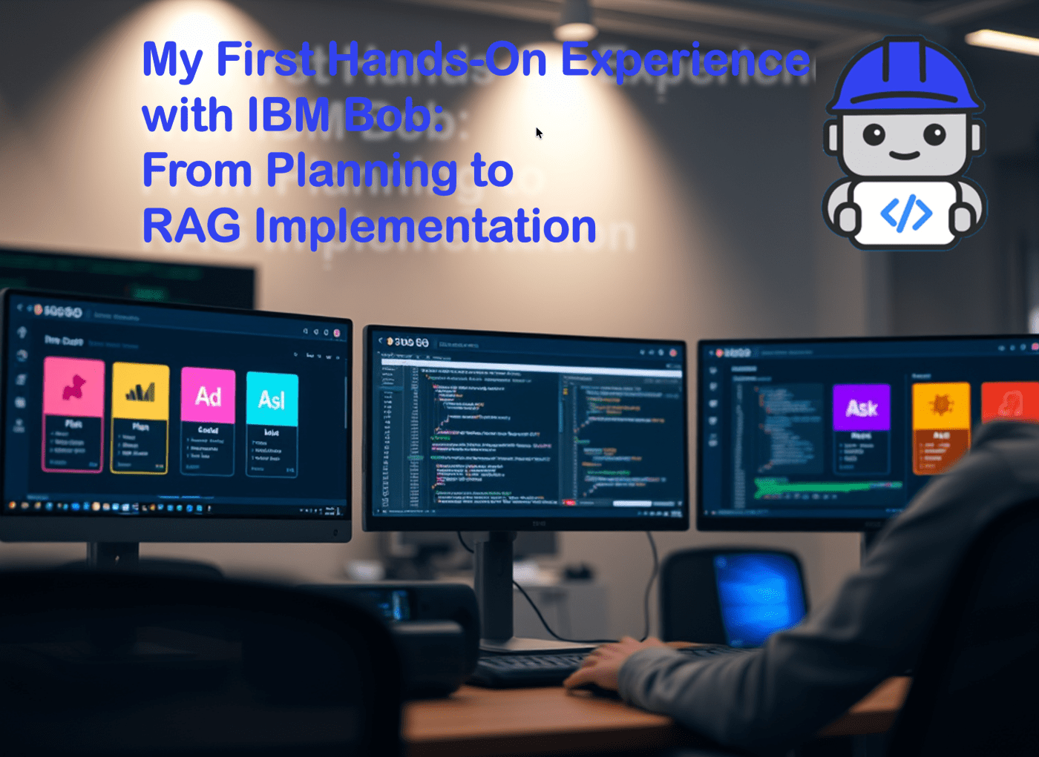
In this post, I share my initial experiences with IBM Bob, an AI SDLC tool. By discuss setting it up with VS Code, its configurable modes, and key features. I show some details using IBM Bob to build a RAG system, highlighting its impressive support for planning, coding, and documentation, enhancing workflow efficiency.
- Introduction
- First Impressions of IBM Bob
  - Supported IDEs and Setup
  - Modes in IBM Bob
  - Key Features
- The prompt I provided to IBM Bob
- The interaction
  - Generating the initial idea and the plan for the solution
  - Initial plan
  - Start Implementation
- Summary and Personal Takeaways
- Additional Resources
1. Introduction
This is my first post of the new year 2026, and I am happy to finally have access to IBM Bob. In this post, I share my first hands-on impressions of using it.
After the download and setup, I was happy to get my first personal experience with IBM Bob and how it feels to use it, and how it can support both developer and architect roles.
I noticed there are many posts out there that share their first steps, and IBM Bob is powerful.
Therefore, I avoided writing an overly trivial or straightforward initial prompt when I started with a first example test.
I wanted IBM Bob to help me build a fairly common RAG scenario using IBM Cloud services and IBM watsonx tooling.
For those readers who don’t know IBM Bob, IBM Bob can be your AI SDLC tool that augments existing workflows, helping you plan, code, tackle advanced topics, or answer questions related to your codebases.
Some existing posts and videos about Bob:
- Fixing Errors in the AI-based IDE Project Bob (Niklas Heidloff)
- IBM enters the AI-native IDE game! Meet Bob! (Maximilian Jesch)
2. First Impressions of IBM Bob
Here is what I did and my first close hands-on experience with the IDE.
2.1. Supported IDEs and Setup
I use it in VS Code. I was able to use my standard VS Code extensions and import it; there was a good setup and introduction wizard.
2.2. Modes in IBM Bob
I noticed that IBM Bob provides configurable Modes: “Modes are specialized personas that tailor Bob’s behavior for your specific tasks. Each mode offers different capabilities and access levels to help you accomplish particular goals more efficiently.”
IBM Bob was coming with four default modes:
- Plan
- Code
- Advanced
- Ask
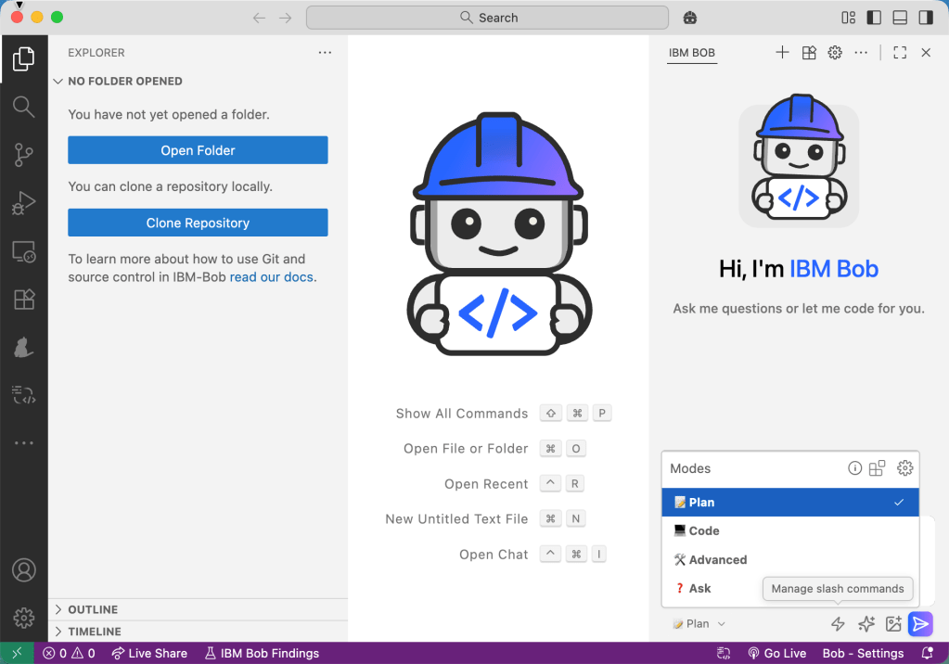
2.3 Key Features
- Configuration of the Modes for Bob
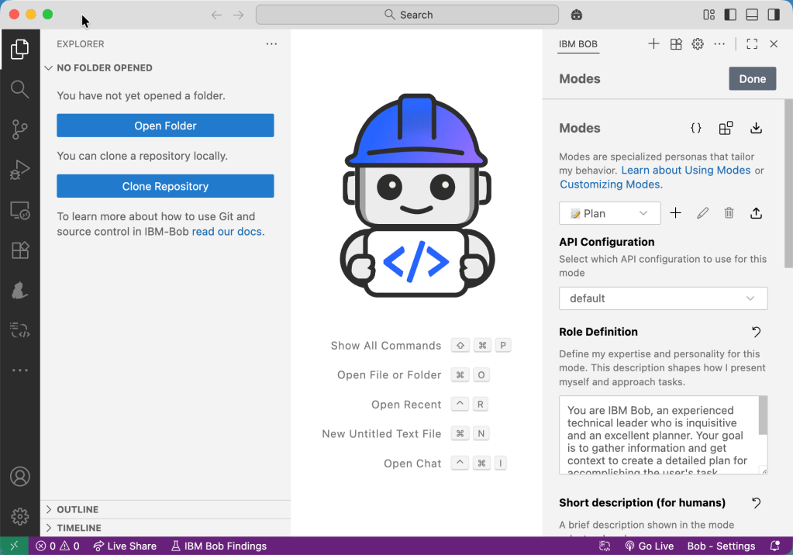
- Autocomplete
- Bob’s Tips
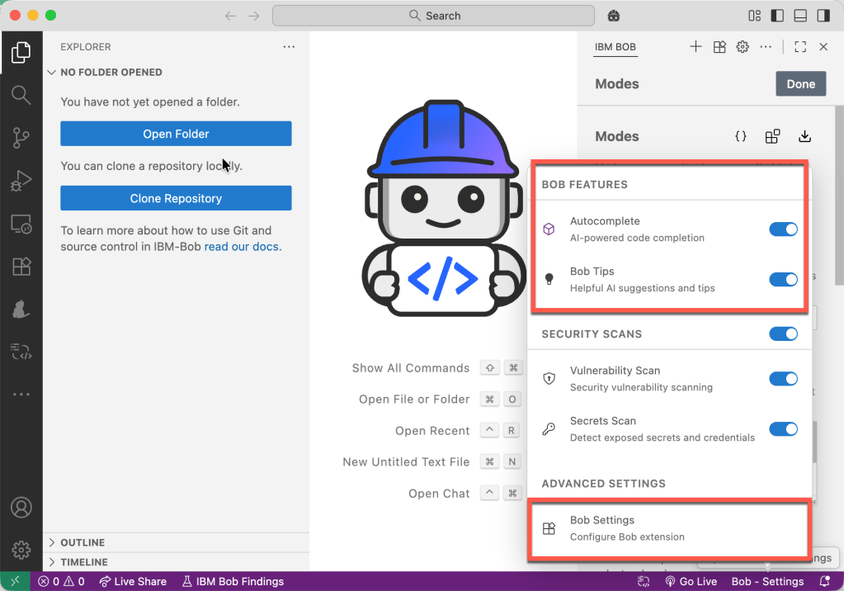
3. The prompt I provided to IBM Bob
The following text is the full prompt I provided IBM Bob to start with. The prompt includes a use case that should cover a not-too-simple RAG situation because, if the question contains more than 20,000 words, the embedding and the vector search must be handled so that the search query in the vector DB will provide useful and relevant answers.
So the prompt includes the use case and some architectural and technological constraints.
## 1. Use Case
Building **BobDB Studio RAG Helper**
​
The objective is to build a RAG (Retrieval-Augmented Generation) system that provides efficient, fast searches and summarizations to solve technical problems for a specific product. Queries may include additional context, such as logs or configuration files, with a token count exceeding 20,000.
​
Help information for this product is available in a complex format across multiple JSON files.
​
To enable consumption by other AI tools, in conversational or non-conversational applications, the RAG access must be implemented as an agent or tool available on an MCP (Model Context Protocol) server, or through an A2A (Agent-to-Agent) communication setup.
​
## 2. Architecture boundaries
### 2.1 Preprocessing and simplifying a complex JSON
​
#### 2.1.1 Example complex JSON
​
This is an example complex JSON generated with AI you should use.
​
```json
{"tool": {
"name": "BobDB Studio",
"type": "database administration & observability",
"cli": "bobdb",
"version": "2.3.0"
},
"troubleshooting_catalog": [{
"id": "BDB-005",
"title": "Backup job failure due to storage quota exceeded",
"component": "Backup Service",
"severity": "medium",
"frequency": "occasional",
"symptoms": ["Backup job exits with code 17", "Error: quota exceeded", "No recent full backups available"],
"identification": { "quick_checks": [ {
"step_id": "QC-040",
"description": "Check backup job status",
"command": "bobdb backup status --latest"
}],
"metrics": [{
"name": "backup_storage_utilization_pct",
"operator": ">=",
"threshold": 95,
"sampling_period": "daily",
"source": "ObjectStore",
"example_query": "backup_storage_used_bytes / backup_storage_quota_bytes * 100 >= 95"
}],
"log_patterns": [{
"file": "/var/log/bobdb/backup.log",
"match": "ERROR .* quota exceeded .*",
"timeframe": "last_24h",
"case_sensitive": false
}]
},
"root_causes": [{ "cause": "Retention policy misconfigured (no pruning)",
"likelihood_pct": 60 }],
"solutions": [{
"solution_id": "SOL-005A",
"title": "Enable pruning according to retention policy",
"type": "configuration",
"steps": [{ "step_no": 1, "action": "Set retention", "config_file": "/etc/bobdb/backup.yaml", "key": "retention.days", "value": 14 }],
"validation": ["bobdb storage quota show --target s3://backups/bobdb", "Ensure utilization < 80%"]
}],
"applies_to": { "versions": [">=1.9.0"], "platforms": ["cloud", "on-prem"] },
"tags": ["backup", "storage", "retention"]
}]
}
```
​
#### 2.1.2 Tools, Products, and Frameworks Used for Implementation
​
* Docling for preprocessing
* Python
* FastAPI server
* JSON upload
* JSON download
* JSON preprocessing
​
* IBM Cloud Object Storage
* Store JSON data
​
### 2.2 Ingestion Pipeline
​
#### Using the Output from Preprocessing
​
The ingestion pipeline will consume the REST API from the data preprocessing application.
​
#### 2.2.2 Tools, Products, and Frameworks Used for Implementation

- watsonx.data
- Milvus Vector DB
- Python
- FastAPI server
- Generate embeddings with a model on watsonx.ai
​
### 2.3 RAG Inference Provided by an MCP Server or via Agent-to-Agent Communication
​
The tool or the new agent must be integrated within watsonx Orchestrate.
4. The interaction
Here are some of my interactions with IBM Bob.
4.1 Generating the initial idea and the plan for the solution
Before Bob started planning based on my input prompt, it asked for a few clarifications to better understand what exactly needed to be done.
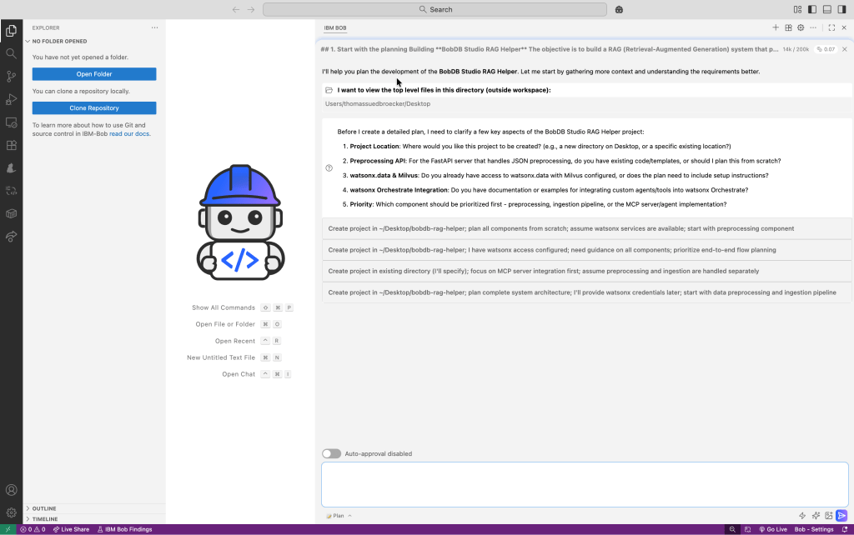
Here is my response to Bob’s follow-up questions:
1. Project location: /dev/bobdb_studio_rag_helper
2. Plan from scratch based on all the information you currently have.
3. With the setup plan and how to access.
4. You must all provide the information and steps from scratch!
5. You must go step by step from preprocessing, to ingestion pipeline, to a MCP server/agent implementation!
4.2 Initial plan
Then Bob generates the initial plan. I had switched off auto-approve because I wanted to verify each generation step and understand what Bob generated.
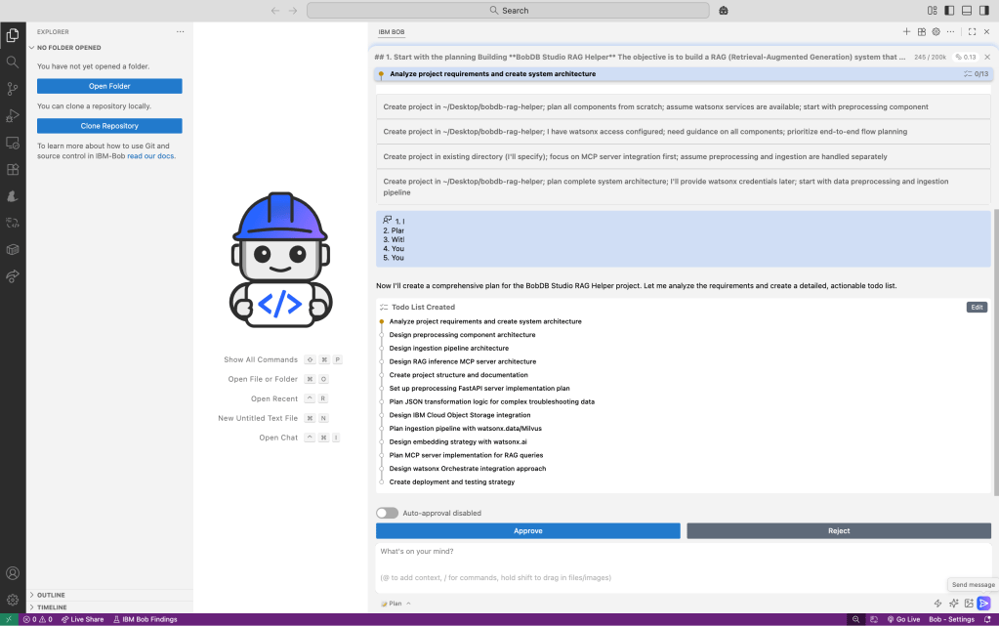
These are some additional steps Bob did:
- fetch detailed instructions to assist with the current task
- Generate an architecture document
- Generate an implementation plan
- Generate a Setup Guide
- Generate a checkpoint readme
- Generate a configuration guide
- Generate a planning summary
4.3 Start Implementation
Here I need to switch to code mode.
I copied and pasted the summary and started a new task by pressing Send Message!
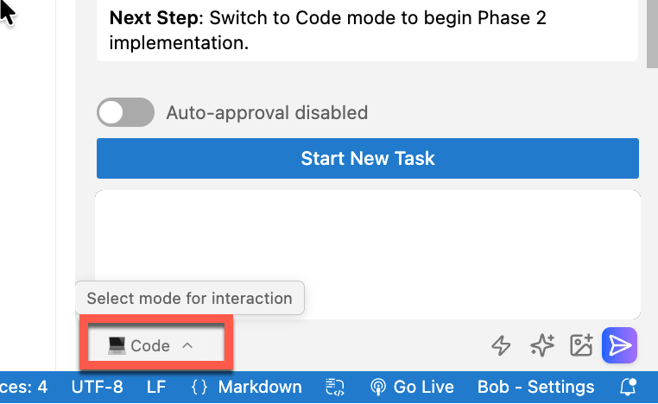
5. Summary and Personal Takeaways
My personal summary.
It was very impressive to see how Bob supports the workflow for the entire process—from planning to coding—especially for this non-trivial use case.
This is why I chose a common RAG help use case—one where I can verify the technical outcome—since I have applied similar scenarios in several use cases in the past. I wanted to share with you the feeling and the impression I got when I got my hands dirty for the first time with IBM Bob.
It is awesome that you can verify each step, and your input will be used for the next steps.
The outcome of planning, the architecture documentation, the implementation plan, the initial testing, and the documentation for the setup was impressive. Everything was delivered in a very structured and easily consumable way.
Sure, you should understand what IBM Bob generated and how the technology works. With this in mind, this is a real booster for your planning, documentation, testing, and system implementation, by enabling you to be much faster.
Let’s see when IBM Bob will be more widely available to other users.
FYI: Here is a video where I used Bob to build an agent inside watsonx Orchestrate.
6. Additional Resources
If you want to explore IBM Bob, RAG architectures, and the underlying IBM AI ecosystem in more detail, the following resources are helpful starting points:
6.1 IBM Bob
- IBM Project Bob (AI-Native IDE)
https://www.ibm.com/products/project-bob
- Fixing Errors in the AI-based IDE Project Bob – Niklas Heidloff
https://heidloff.net/article/fixing-errors-ai-based-ide-project-bob/
- IBM enters the AI-native IDE game! Meet Bob! – Maximilian Jesch
https://maximilianjesch.com/ibm-enters-the-ai-native-ide-game-meet-bob/
6.2 Retrieval-Augmented Generation (RAG)
- Retrieval-Augmented Generation (RAG) – IBM Research Overview
https://research.ibm.com/blog/retrieval-augmented-generation
- What is RAG? – IBM Developer
https://developer.ibm.com/articles/what-is-retrieval-augmented-generation-rag/
- RAG is Dead … Long Live RAG (Thomas Südbröcker)
6.3 IBM watsonx and AI Platform
- IBM watsonx Overview
https://www.ibm.com/watsonx
- watsonx.ai Documentation
https://www.ibm.com/docs/en/watsonx-ai
- watsonx Orchestrate
https://www.ibm.com/products/watsonx-orchestrate
6.4 Vector Databases and Ingestion
- Milvus Vector Database
https://milvus.io/
- watsonx.data
https://www.ibm.com/products/watsonx-data
6.5 Developer Tooling
- Visual Studio Code
https://code.visualstudio.com/
- FastAPI
https://fastapi.tiangolo.com/

I hope this was useful to you and let’s see what’s next?
Greetings,
Thomas
#IBM, #watsonx, #IBMCloud, #EnterpriseAI, #CloudArchitecture
Share this:
- X
- Facebook

Related
Using IBM Bob, MCP, and watsonx Orchestrate to Generate an AgentMarch 29, 2026In "ai"
The Rise of Multi-Model Engineering: Is IBM Bob Already Built for the Next Phase?July 31, 2026In "ai"
From first ideas to a working MCP server for Astra DB CRUD tools with IBM BobFebruary 3, 2026In "ai"

Published by thomassuedbroecker
My name is Thomas Suedbroecker and I work for IBM. I am a customer-oriented, team-oriented and open person, I focus on business success, client's success, innovation and skills. All opinions in my blog posts are my own. My objective is to provide developers help and guides, to enable themself on Cloud development topics and of course the relevant usage of the Development and Operations. I like music and creating own music by playing drums and I started playing the e-guitar (very beginning ;-)). View all posts by thomassuedbroecker
January 7, 2026
#watsonx.ai, ai, ibm_bob
#CloudArchitecture, #EnterpriseAI, #IBM, #IBMCloud, #watsonx, technology
Post navigation
A Music AI Video Generation: Run Local, Offline, and Free on macOS
A Bash Cheat Sheet: Adding a Model to Local watsonx Orchestrate
Leave a comment
vv

Supercharge Your Support: Example Build & Orchestrate AI Agents with watsonx.ai and watsonx Orchestrate

This post shows how to build, test, and orchestrate AI support agents using IBM’s watsonx.ai and watsonx Orchestrate. You’ll get into the following topics written for an advanced beginner to intermediate level on IBM Cloud, watsonx.ai, and watsonx Orchestrate audience:
- Using the example for the development of an “Specialist Support Agent for DB2”
- Integrate that agent into watsonx Orchestrate
- Build a multi-agent orchestration
- Review step-by-step setup
- Summary and Best Practices
This blog post is in context for the blog post Develop and Deploy Custom AI Agents to watsonx.ai on IBM Cloud.
It describes developing a “Specialist Support Agent for DB2” available in the workshop material for the regional techXchange in Germany.
This gif shows the usage of the “Specialist Support Agent for DB2” running in watsonx.ai into a “Support Agent” running in the watsonx Orchestrate “Agent Builder”:

1. Motivation
IBM’s watsonx Orchestrate has introduced powerful new capabilities for agent-based workflows. By leveraging the watsonx.ai Agent Template and LangGraph, you can develop custom AI agents locally and seamlessly import them into watsonx Orchestrate.
Based on this news, I want to highlight how it is possible to add an agent locally developed based on the watsonx.ai Agent template made by watsonx developer hub.
2. Starting Point: Specialist Support Agent for DB2
In the workshop material for the regional techXchange in Germany, you can follow the steps to develop a support agent for DB2 locally that utilizes two capabilities generated before one: an email outline that can be sent to the customer and second, a RAD implementation to answer questions related to DB2 as tools. Developed with LangGraph.
- Here is a description for this Specialist Support Agent for DB2
We can say this agent is a support expert for level one to level two to answer questions and provide an initial email outline for support members to be more effective. This agent can find the answers to complex questions by accessing DB2 documentation. If you request an outline for an email to send to a customer, it can outline this.
In the Regional TechXchange workshop material, we built a Specialist Support Agent for DB2. This agent:
- Generates an email outline to communicate with customers.
- Answers DB2-related questions by querying the official DB2 documentation.
The image below shows the simplified dependencies for this agent.
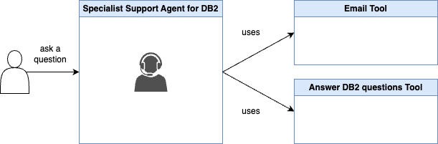
3. Evolving to Multi-Agent Orchestration
Now, we can easily integrate this agent to watsonx Orchestrate from a deployment in watsonx.ai.
With watsonx Orchestrate, you can combine multiple specialist agents to create an orchestrator support agent which:
- Receives user requests about various IBM Software or Cloud services
- Routes questions to the appropriate specialist agent (e.g., DB2, IBM Cloud Services)
- Aggregates responses and sends a unified reply
Here is a description of this Support Agent (orchestrator)
The agent can answer easy and complex questions about various products; therefore, the support agent uses the specialist agents in his ‘toolset’ transfers to specialist support agents to answer support questions about the products the specialist support agents are responsible for. The amount of specialist support agents can change in the future.
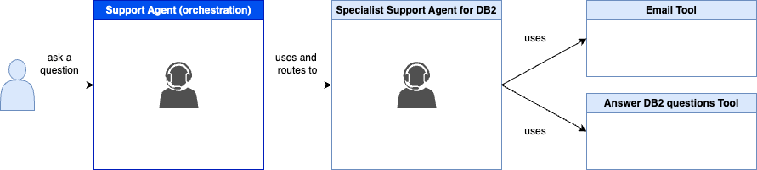
4. Integration Overview: watsonx.ai and watsonx Orchestrate
With this we can realize following scenario to create an orchestration support agent. In this context, it is useful to understand the terminology of three agent types.
To learn more about agent orchestration concepts and terminology::
- Blog: Integrating watsonx.ai Agents in watsonx Orchestrate
- IBM watsonx Orchestrate documentation: Adding agents for orchestration
- IBM Think 2025 article: What is AI agent orchestration?
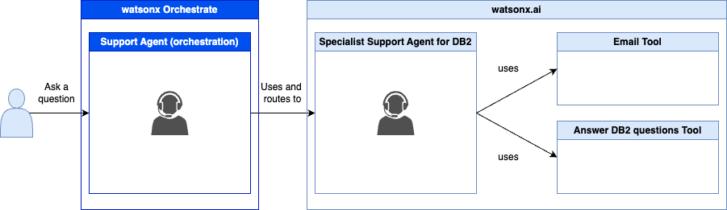
The image below simplifies technical dependencies based on the last blog post and the workshop documentation for the Specialist Support Agent for DB2 and the new orchestration agent we will create in watsonx Orchestrate.
The agent in the watsonx.ai deployment was locally developed and then deployed to watsonx.ai.(more details about the right part of the image you can find in the blog post Develop and Deploy Custom AI Agents to watsonx.ai on IBM Cloud)
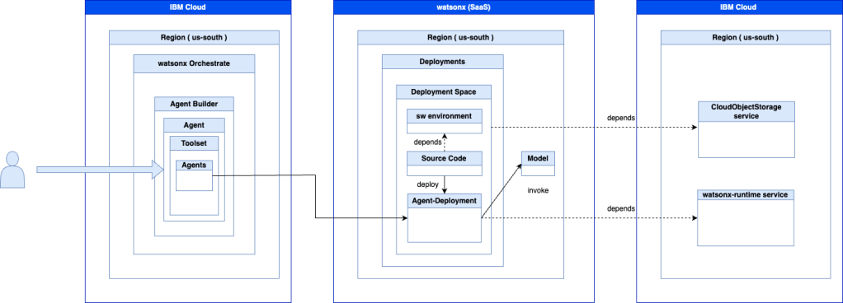
5. Easy Setup: Importing Your Agent into watsonx Orchestrate
The setup watsonx.ai and watsonx Orchestrate
Step 1: Select the Agent Builder
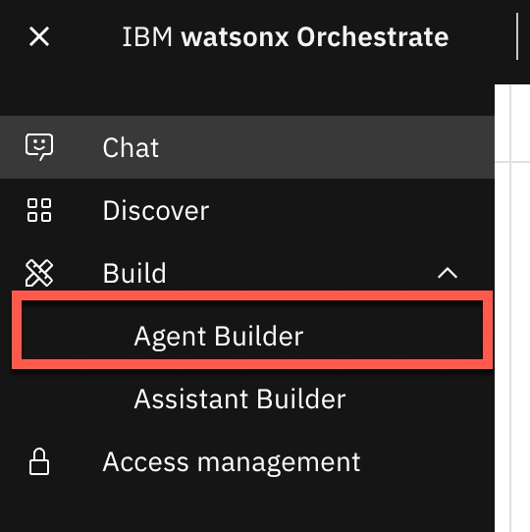
Step 2: Select Create Agent from scratch
Enter a name and description, then click Create.
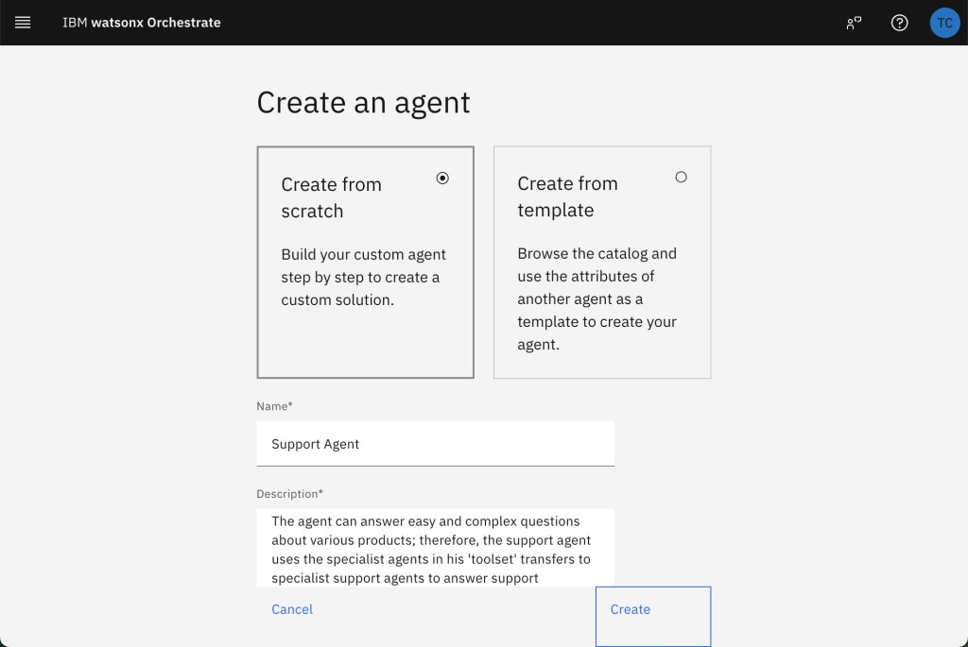
Step 3: Specify the Knowledge
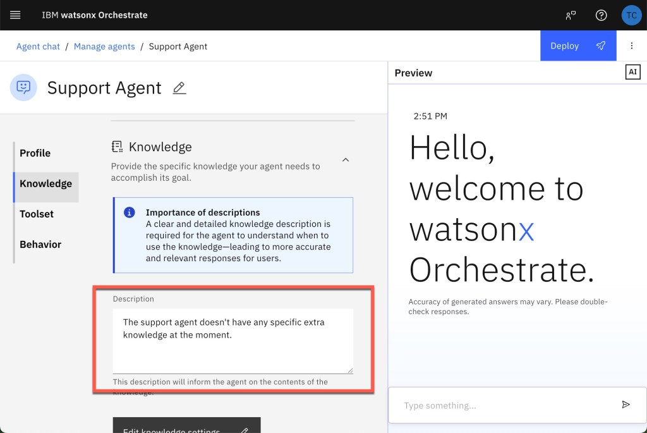
Step 4: Add an agent
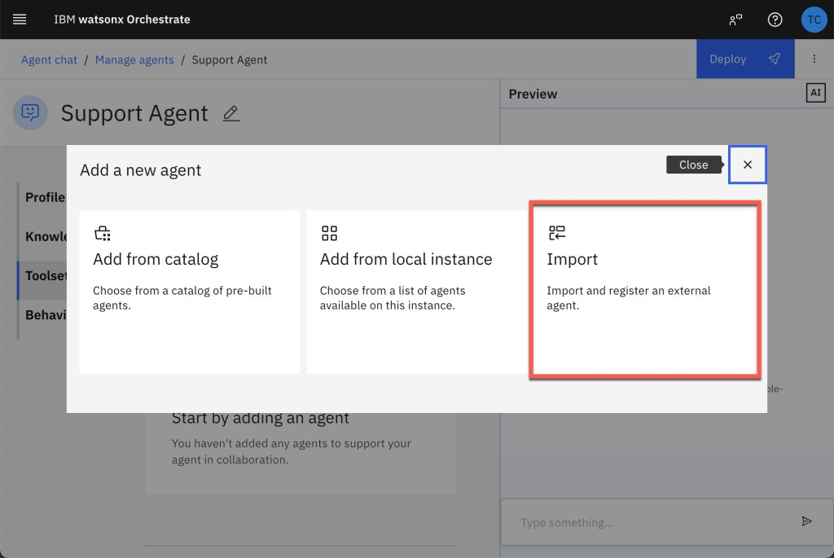
Step 5: Select “Import”

Step 6: Select “External agent”
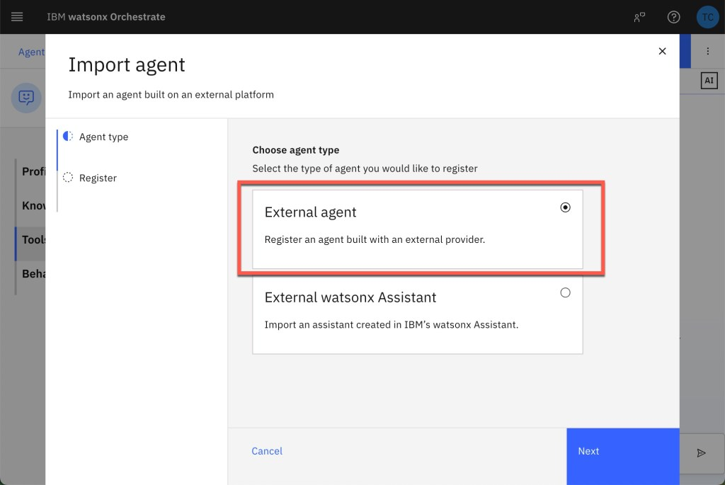
Step 7: Insert the IBM Cloud API key
Choose watsonx.ai and enter your IBM Cloud API key for the watsonx Runtime service.
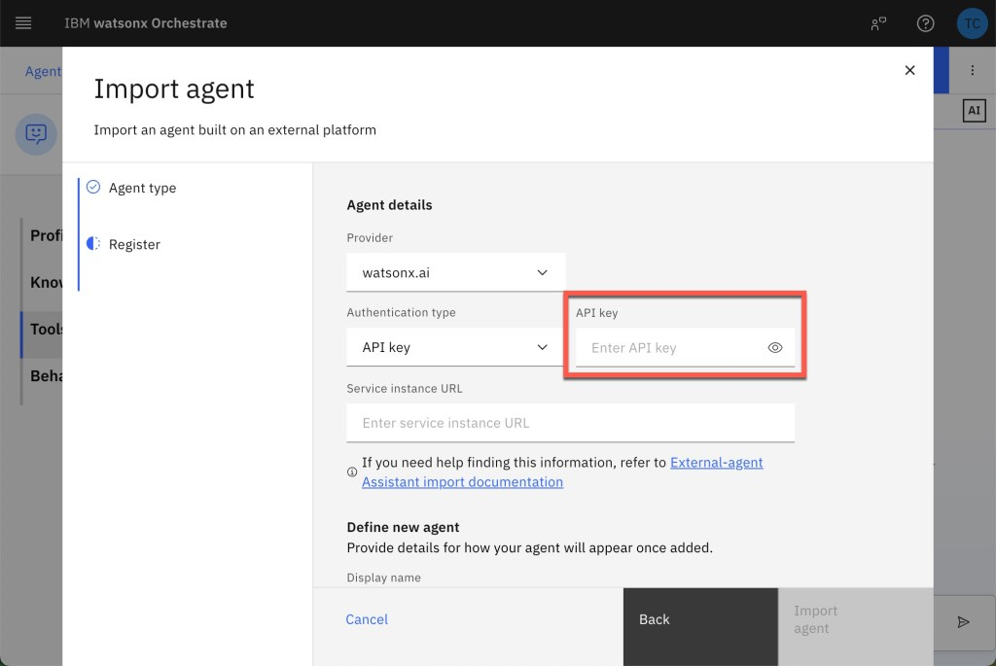
Step 8: Enter the Service instance URL
Paste the stream URL from your watsonx.ai agent deployment.
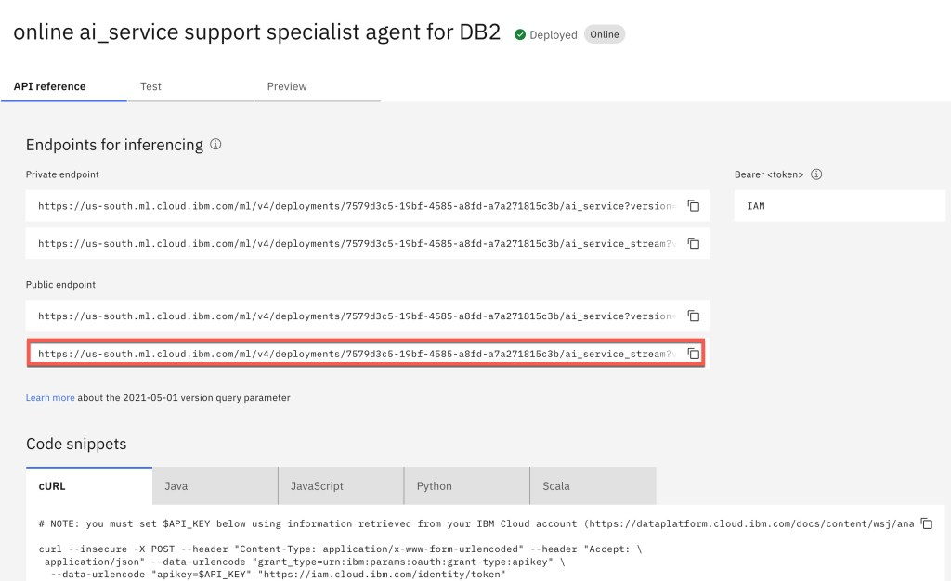
Step 9: Define your agent and import the agent
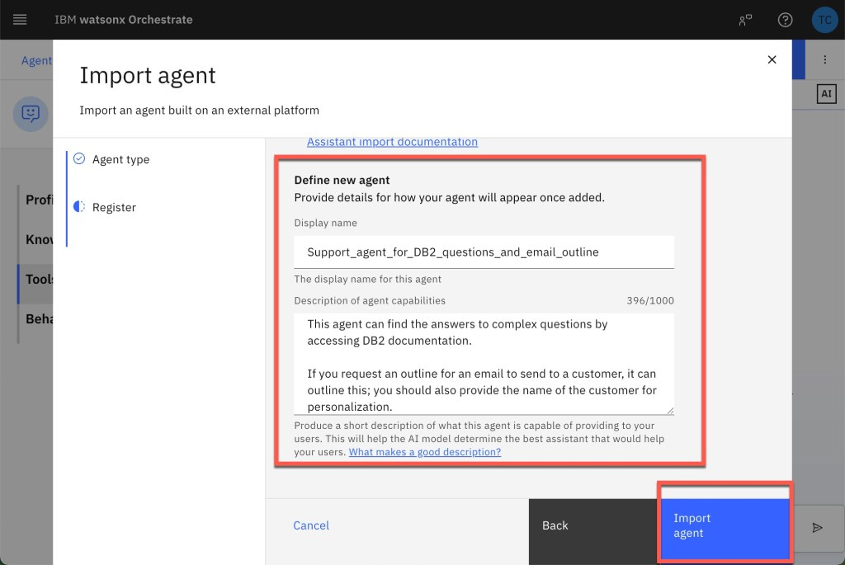
Step 10: Verify the agent is imported
Custom tools won’t appear in the tool listed but are ready to use for the DB2 agent.
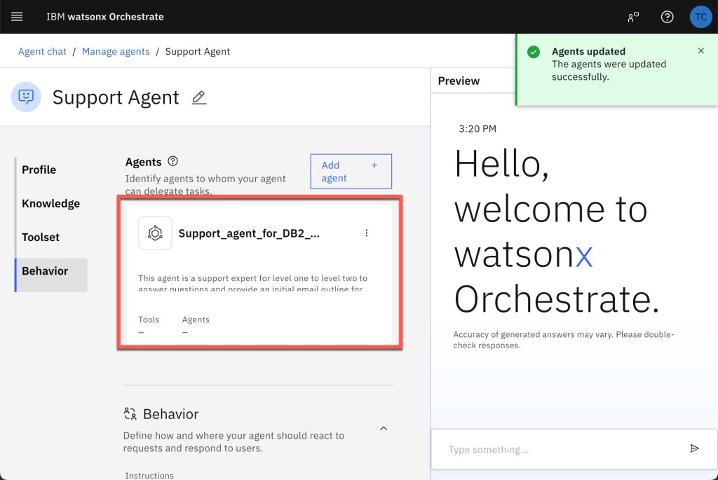
Step 11: Add the Behavior
Configure orchestrator agent instructions to interact with the user and use the DB2 agent.
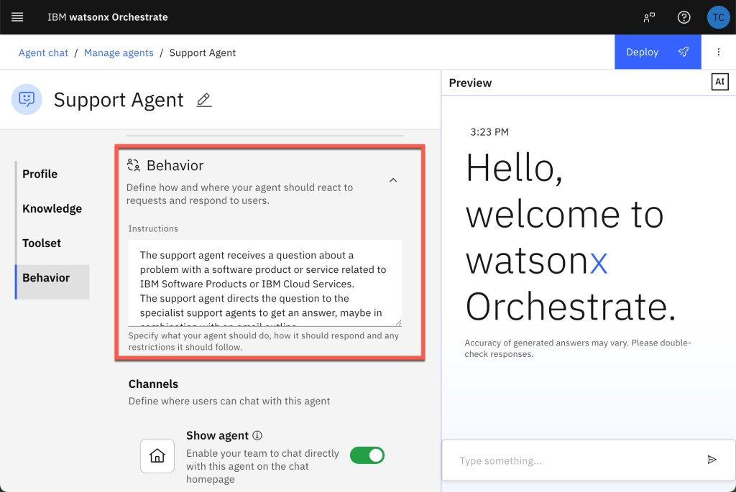
Step 12: Test the support agent (orchestrator)
As you can see the support agent uses our developed DB2 support agent and also spelling errors in the question. Now we are ready to use the multi agent implementation with the orchestrator agent in watsonx Orchestrate

6. Summary and Best Practices
This is a good Modular Design we were able to build a specialist agent focused on a single domain, then connect them through an orchestrator support agent.
By following these patterns, you can rapidly develop, deploy, and orchestrate custom AI agents in the watsonx ecosystem. bIntegrating agents locally developed based on the watsonx.ai Agent template made by the watsonx developer hub can easily be imported into watsonx Orchestrate that’s awesome.
But you should remember, when creating multi-agent systems, don’t expect they are always correct, because you introduce multiple time interactions with a large language model. The image below should visualize how many prompts are involved in different scenarios, for example an SQL response summarization using Supervisor and several agents and tools using four large language model interactions. Which is the maximum on accuracy to expect? When, at the moment, an accuracy for a large language model integration with 0.9 is seen as a good value?
You should be aware of:
- Error handling: Multi-agent workflows introduce multiple LLM calls—monitor latency and accuracy. (Exploring the “AI Operational Complexity Cube idea” for Testing Applications integrating LLMs)
- Have the right performance expectations: Aim for at least 90% accuracy in each agent; orchestration adds complexity and potential error.
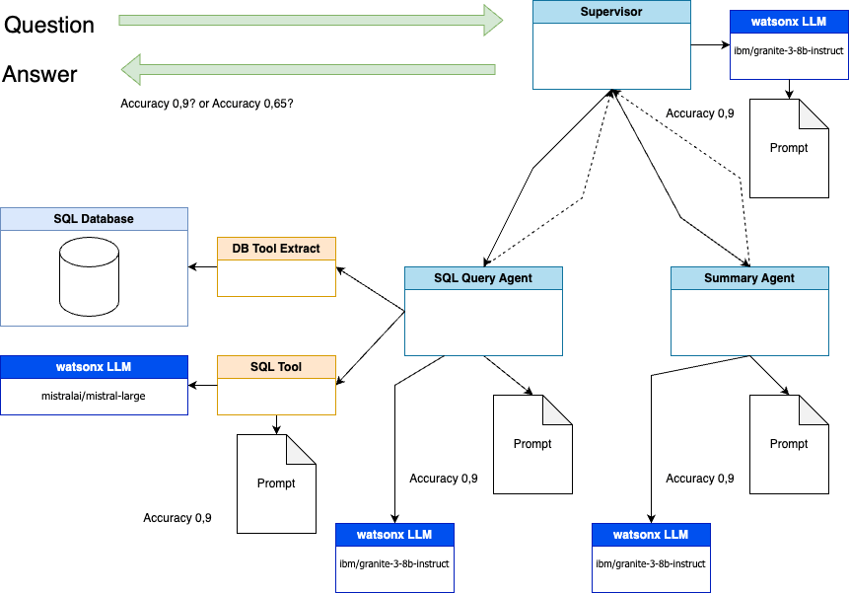
The diagram above illustrates a multi-agent supervisor pattern—how a top-level agent routes an incoming user question to two specialist agents (a SQL Query Agent and a Summary Agent), then aggregates their outputs into a final answer:
- Supervisor Agent (watsonx LLM “ibm/granite-3-bb-instruct”)
  - Receives the user’s Question (green arrow in).
  - Decides, based on its own prompting logic, which specialist agent(s) should handle the request. Dashed lines indicate possible routing decisions, each stamped with an estimated accuracy (e.g. 0.9 when it hands off to a given agent, or lower if uncertain).
- SQL Query Agent
  - When tasked, it uses a DB Tool Extract component to read from an underlying SQL Database,
  - Sends the extracted data to an SQL Tool (backed by another LLM instance, here “mistralai/mistral-large”) , which formulates and executes database queries according to a provided Prompt.
  - Returns query results, again annotated with an accuracy estimate (0.9).
- Summary Agent
  - Independently, another copy of the same watsonx LLM (“ibm/granite-3-bb-instruct”) ingests the raw question or intermediate data and produces a human-friendly summary or analysis per its Prompt, also at ~0.9 accuracy.
- Aggregation Back at the Supervisor
  - The Supervisor collects the SQL results and the summary output, applies its own final prompting step (shown as the little “Prompt” icon next to the Supervisor), and emits the unified Answer (green arrow out).
  - Accuracy annotations (e.g. “Accuracy 0.9? or Accuracy 0.65?”) hint at how confidence scores might guide whether the Supervisor trusts or re-routes tasks for re-execution.
This flow demonstrates how distinct “worker” agents—each with their own tools and LLM models are orchestrated by a Supervisor to handle complex, multi-step queries against data sources like a SQL database, then combine their outputs into a single coherent response.

I hope this was useful to you and let’s see what’s next?
Greetings,
Thomas
#AIAgents, #watsonxai, #IBMCloud, #AgentOrchestration, #LangGraph, #DB2Support, #watsonxOrchestrate, #CustomAIWorkflows, #DeveloperTutorial, #MultiAgentSystems
Share this:
- X
- Facebook

Related
Getting Started with Local AI Agents in the watsonx Orchestrate Development EditionJune 25, 2025In "ai"
Build, Export & Import a watsonx Orchestrate Agent with the Agent Development Kit (ADK)July 8, 2025In "ai"
Access watsonx Orchestrate functionality over an MCP serverNovember 13, 2025In "cloud"

Published by thomassuedbroecker
My name is Thomas Suedbroecker and I work for IBM. I am a customer-oriented, team-oriented and open person, I focus on business success, client's success, innovation and skills. All opinions in my blog posts are my own. My objective is to provide developers help and guides, to enable themself on Cloud development topics and of course the relevant usage of the Development and Operations. I like music and creating own music by playing drums and I started playing the e-guitar (very beginning ;-)). View all posts by thomassuedbroecker
May 15, 2025
#watsonx.ai, cloud, watsonx Orchestrate
#AgentOrchestration, #aiagents, #CustomAIWorkflows, #DB2Support, #DeveloperTutorial, #IBMCloud, #langgraph, #watsonx.ai, #watsonxOrchestrate
Post navigation
Exploring the “AI Operational Complexity Cube idea” for Testing Applications integrating LLMs
The Rise of Agentic AI and Managing Expectations
5 thoughts on “Supercharge Your Support: Example Build & Orchestrate AI Agents with watsonx.ai and watsonx Orchestrate”
Add yours
- Pingback: The Rise of Agentic AI and Managing Expectations – Thomas Suedbroecker's Blog
- Pingback: Getting Started with Local AI Agents in the watsonx Orchestrate Developer Edition – Thomas Suedbroecker's Blog
- Pingback: Build, Export & Import a watsonx Orchestrate Agent with ADK – Thomas Suedbroecker's Blog
- Pingback: REST API Usage with the watsonx Orchestrate Developer Edition locally: An Example Guide – Thomas Suedbroecker's Blog
- Pingback: Integrating watsonx Orchestrate Agent Chat in Web Apps – Thomas Suedbroecker's Blog
Leave a comment

i3_Academy_IBM_TechXchange_Hackathon_Briefing

